Database System Engineering and Distributed Backend Development
Course Code: 25CS13002E
WEEK-1 2520030531
D. Venya Sri

Query 1 — Create Database
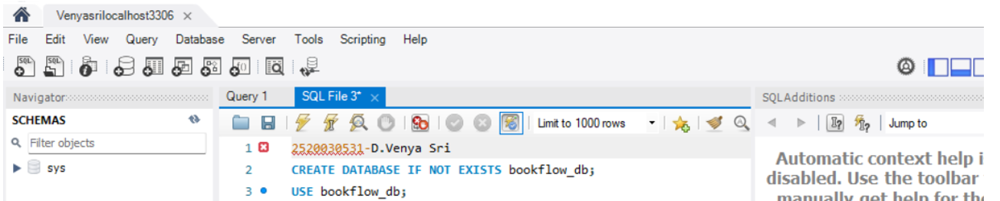
OUTPUT

Query 2 – Select the Database
OUTPUT

Query – 3 Create the books table
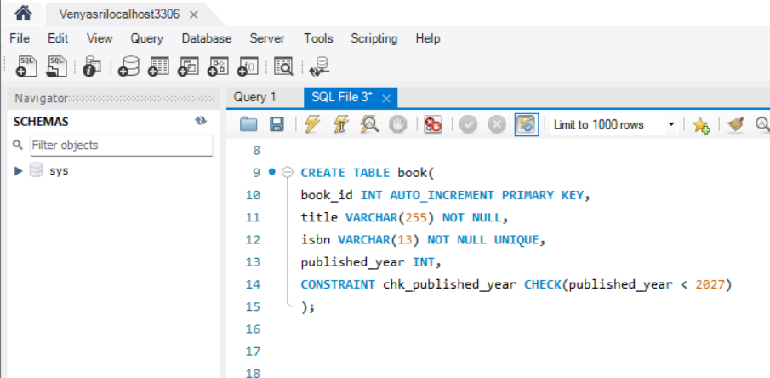
OUTPUT

Query – 4 Create the members table
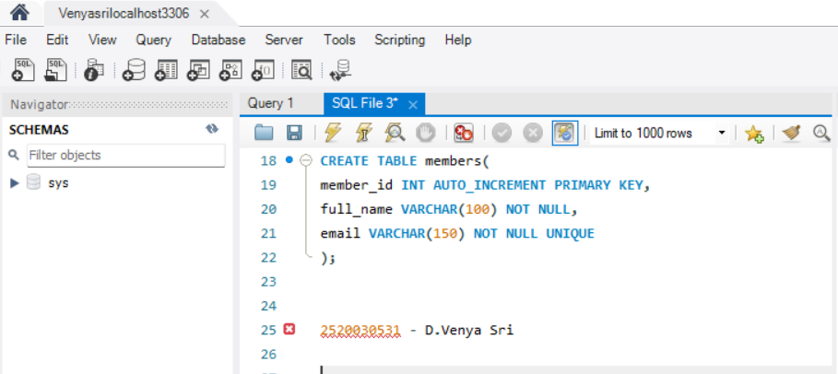

OUTPUT

Query – 5 (verification): Inspect the table structures:
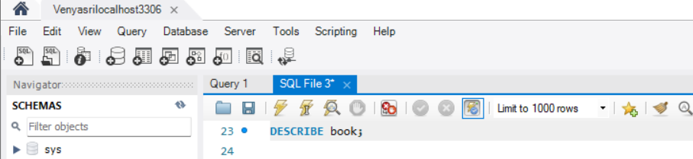
OUTPUT
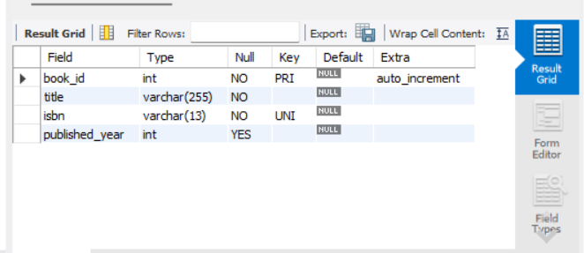

Query – 6:
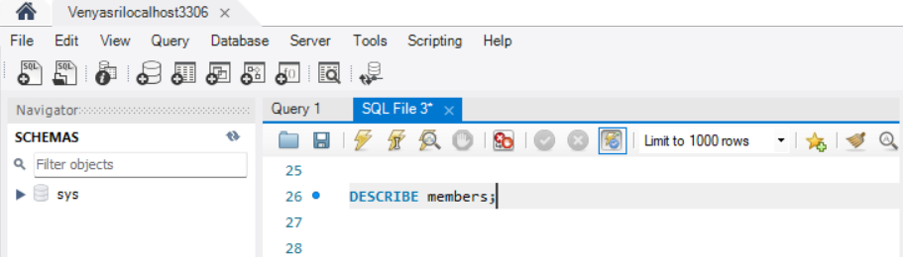
OUTPUT
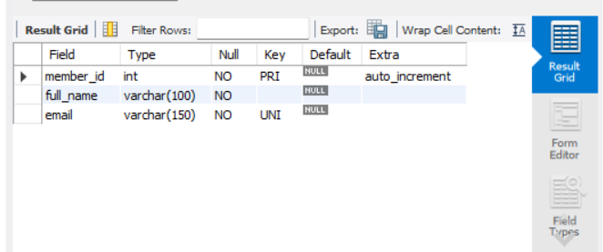

Query – 7 Insert 3 books
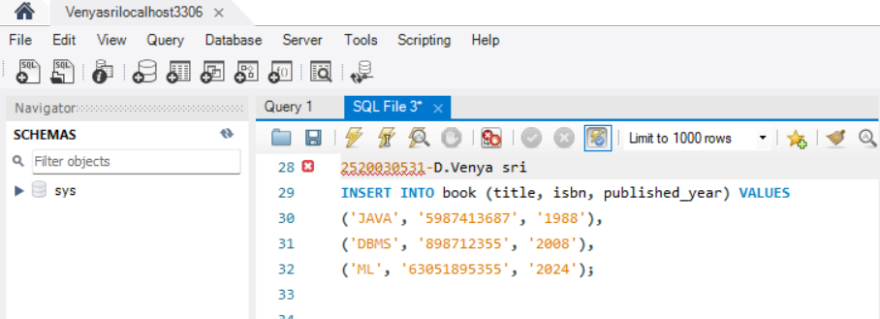
OUTPUT

Query – 8:
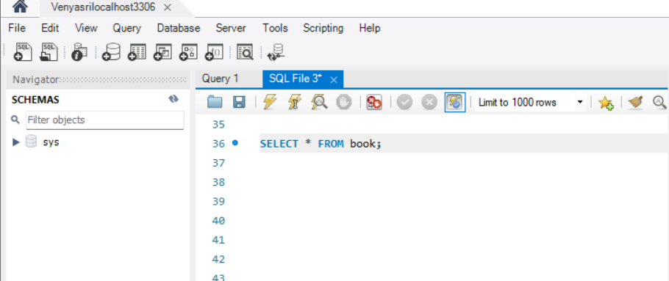
OUTPUT
